**Project Impact Factors Survey**

This survey aims to study the factors affecting the success and failure of projects, with a particular focus on the impact of organizational structure changes on projects. It is jointly completed by an academic research team and professional personnel (ensuring that the data collected by the questionnaire is used solely for academic research). The questionnaire covers academic and general knowledge issues and explores the intentions of corporate personnel to use tools (such as visual modeling) to support the management of organizational structures. To thank you for carefully completing the questionnaire, red packet rewards will be randomly drawn and distributed from valid questionnaires after collection.

**1. Your years of work experience\***

- Less than 1 year

- 1-5 years

- 6-10 years

- More than 11 years

**2. The nature of your company\***

- Private

- State-owned and state-controlled

- Foreign-funded enterprise

- Government and public institutions

- Other______

**3. Have you ever been involved in a failed project (loss/severe delay/incomplete/budget overrun/failure to meet the client's requirements, etc.)?\***

- Yes

- No

**4. What type of project was the failed project you participated in?* [Multiple-choice question]**

- Desktop application

- Web application

- Mobile application

- Infrastructure application (database, operating system)

- Other______

- Depends on the first option of [3. Have you ever been involved in...]

**5. What type of project have you recently been responsible for or participated in?* [Multiple-choice question]**

- Desktop application

- Web application

- Mobile application

- Infrastructure application (database, operating system)

- Other______

- Depends on the second option of [3. Have you ever been involved in...]

**6. What role do you play in the project?\***

- Manager (Control of the overall project framework, and helping the development team solve problems)

- Development team (Personnel who perform actual development work)

- Product owner (Representing customers and stakeholders in communication with developers, determining customer needs, and helping customers continuously follow up on the project)

- Other______

**7. What specific work is your position responsible for in the project?\***

**8. The historical years of your company\***

- 1-5 years

- 6-10 years

- 11-15 years

- More than 15 years

**9. The organizational scale of the project you participated in\***

- Micro (1-9 people)

- Small (10-49 people)

- Medium (50-249 people)

- Large (250-1999 people)

- Extra large (more than 2000 people)

**10. The budget of the project you recently participated in\***

- Less than 100,000

- 100,000 to 490,000

- 500,000 to 990,000

- 1 million to 4.99 million

- More than 5 million

**11. The expected completion time of your last project\***

- Less than 1 month

- 1 to 3 months

- 4 to 6 months

- 7 to 12 months

- 1 to 2 years

- 2 to 3 years

- More than 3 years

**12. The actual completion time of your last project\***

- Less than 1 month

- 1 to 3 months

- 4 to 6 months

- 7 to 12 months

- 1 to 2 years

- 2 to 3 years

- More than 3 years

**13. Your satisfaction with the project you were responsible for or participated in recently\***

- Very dissatisfied ~ Very satisfied

- 1 ~ 5

**14. The degree of match between actual progress and expected progress\***

- Very dissatisfied ~ Very satisfied

- 1 ~ 5

**15. The communication channels for the projects you participate in* [Multiple-choice question]**

- Face-to-face communication

- Telephone communication

- Online communication

- Email communication

**16. The effectiveness of the selected communication channels in solving problems\***

- Ineffective communication

- Poor effect

- General

- Effective

- Very effective

**17. How often do you think the project promotion and scheduling meetings should be held for the entire project?\***

- More than once a week

- Once a week

- Once every two weeks

- Once a month

- Less frequently

**18. Are you satisfied with the division of individual responsibilities in the project (whether the work tasks are clear, whether the boundaries of responsibilities are clear, and whether the task distribution is fair and reasonable)?\***

- Very dissatisfied ~ Very satisfied

- 1 ~ 5

**19. Do you think the division of departmental responsibilities in the project is important for the project results (whether the work tasks are clear, whether the boundaries of responsibilities are clear, and whether the task distribution is fair and reasonable)?\***

- Not important at all ~ Very important

- 1 ~ 5

**20. Do you have a sound management system and related processes in the project?\***

- Strongly disagree ~ Strongly agree

- 1 ~ 5

**21. Do you think the internal processes of the current project can well support the operation of the project?\***

- Strongly disagree ~ Strongly agree

- 1 ~ 5

**22. Do you think the importance of reporting and feedback at each level in the process of promoting the project?\***

- Not important at all ~ Very important

- 1 ~ 5

**23. How do you think the implementation of reporting and feedback at each level in the process of promoting the project?\***

- Very low execution

- Very high execution

**24. Do you think that some departments have overlapping or misplaced authority in the project?\***

- Strongly disagree ~ Strongly agree

- 1 ~ 5

**25. The personnel changes in the project during your participation:\***

- 0~10%

- 11~30%

- 31~60%

- 61~100%

**26. Do you think the rationality of the vertical management hierarchy in the project will not cause distortion of information as it is passed down?\***

- Strongly disagree ~ Strongly agree

- 1 ~ 5

**27. The cross-departmental horizontal communication in the project is effective and can carry out the work that requires coordination well.\***

- Strongly disagree ~ Strongly agree

- 1 ~ 5

**28. Which organizational structure do you think is more reasonable during the project process?\***

- Tree structure (highly centralized decision-making, problems reflected from the bottom up, high-level decision-making, and execution from top to bottom)

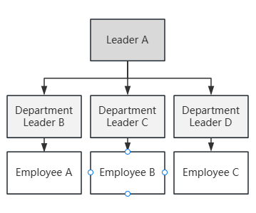

Fig.1 Tree structure

- Ring structure (flat management, reducing intermediate management levels, encouraging direct communication and collaboration between employees and management)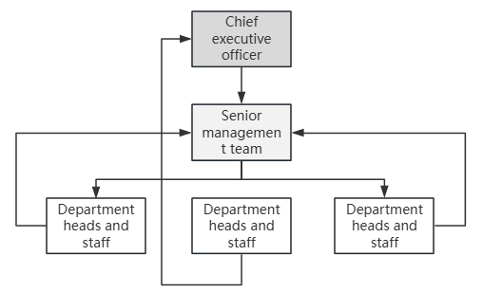

Fig.2 Ring structure

- Forest structure (problems within the department are reflected from the bottom up, and decisions are made by the senior management of each department)

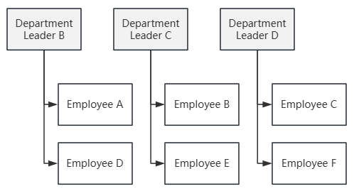

Fig.3 Forest structure

- Graphic structure (open management, free reflection of problems, and joint decision-making by each department)

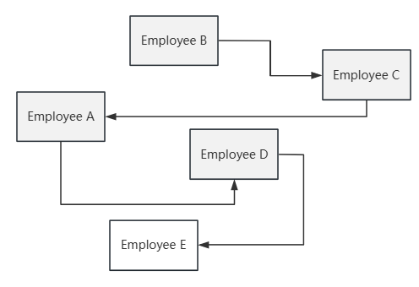

Fig.4 Graphic structure

**29. How important do you think the clarity of project requirements is to the success of the project at the beginning stage?\***

- Not important at all ~ Very important

- 1 ~ 5

**30. How do you think the impact of demand changes on the project during the implementation process?\***

- Not important at all ~ Very important

- 1 ~ 5

**31. Do you think the performance management and incentive system of the department can stimulate the enthusiasm of employees?\***

- Cannot stimulate ~ Can stimulate

- 1 ~ 5

**32. Please score the following factors affecting the progress of the project for their importance.**

- Communication and coordination

- 1 ~ 5

- Decision-making quality

- 1 ~ 5

- Process management

- 1 ~ 5

- Organizational structure

- 1 ~ 5

- Technical implementation

- 1 ~ 5

- Performance incentives

- 1 ~ 5

**33. How do you think the impact of organizational structure on communication and coordination and decision-making quality?\***

- Not important at all

- Not important

- General

- Important

- Very important

**34. Do you think it is necessary to zoom in and out on the organizational modeling diagram when studying organizational issues?\***

- Not necessary at all ~ Very necessary

- 1 ~ 5

**35. Do you think it is necessary to model and compare the ideal structure with the actual structure when the organizational structure changes in software project management?\***

- Not necessary at all ~ Very necessary

- 1 ~ 5

**36. Are you willing to use tools that include zoom-in, zoom-out, and comparative modeling functions when the organizational structure changes to assist in the management of software project organizational structures during the software project process?\***

- Not willing

- General

- Willing

**37. Are you willing to accept one-on-one interviews to contribute to our research work?\***

- Willing

- Not willing

**Please leave your last name and contact information\***

- Depends on the first option of [37. Are you willing to...]

**38. Do you have any other thoughts and suggestions on the research issues of this organizational structure?\***